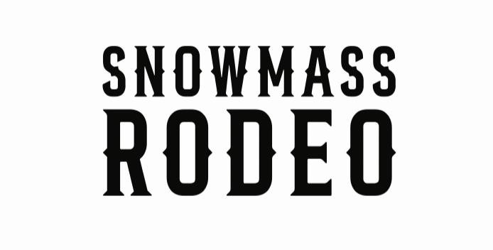
Snowmass Rodeo Scholarship 2023 presented by Snowmass Western Heritage Association
The mission of the Snowmass Western Heritage Association (SWHA) is to inform and educate visitors as well as area residents about the western heritage and character of the Snowmass Village and the Roaring Fork Valley by providing and promoting events and activities that will help preserve and enhance our western heritage, culture and spirit through education and charity.
The Snowmass Rodeo Scholarship Fund seeks to support rodeo contestants, volunteers, and students within the Roaring Fork Valley. To be eligible for scholarship, applicants must attend and volunteer at or compete in 7 of the 9 rodeos throughout the summer WednesdayJune21st
Through August 16th2023. Please sign up by June 1st, 2023 by emailing sponsorsnowmassrodeo@gmail.com Application:
- Name:
- Address:
- Phone: ● Email:
Please draft a letter that includes answers to the following:
- Please share your goals and where you hope to see yourself in five years.
- What activities are you currently involved in and what accomplishments are you most proud of?
- What will scholarship funds, if received, go towards?
In addition to the application, please include:
- A current cumulative grade transcript issued by your institution
- A letter of recommendation
- A resume
Deliver completed applications and accompanying documents to SWHA or email to sponsorsnowmassrodeo@gmail.com by August 9, 2023
Final selection will be announced at the Snowmass Rodeo on Wednesday, August 16th, 2023.
For further information, please visit www.snowmassrodeo.com

